**Proposed Solution:**

Digital banking is being automated currently as it frees up the employees to concentrate on more complex inquiries. Banks are able to automate their customer interactions through chatbots. A good implementation of a chatbot can bring several benefits to the banking sector such as:

24×7 customer service availability: The chatbot is available 24×7 to answer customers questions. This means customers can get their questions answered even during weekends which leads to better customer experience .

Increases productivity of bank personnel: Chatbots can solve minor issues of the customer enabling the bank personnel to deal with major issues and saving their time

Track spending and schedule payment: Chatbot assists customers with paying down debt, checking account status and getting credit score insights. This helps people in keeping track of their expenditures and making sound decisions to stay debt-free.

Assist employees: Chatbots not only serve customers but can also be used to assist employees. They can be used to schedule meetings, send messages between employees and much more.

Personalized marketing: Chatbots can be used to suggest personalized investment options and offers using customers data thereby increasing the conversion rate.

**Architecture:**

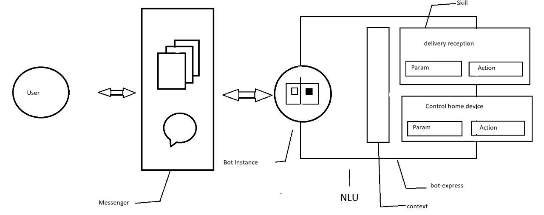

**Components:**

User

Messenger

Bot instance

Software for NLU

Context, parameters and action